CaseManagement_TestForCaseEscalation_Instance29_12-Jul-2018_01-49-59_AM_MouseClickActiononStaleElement.png

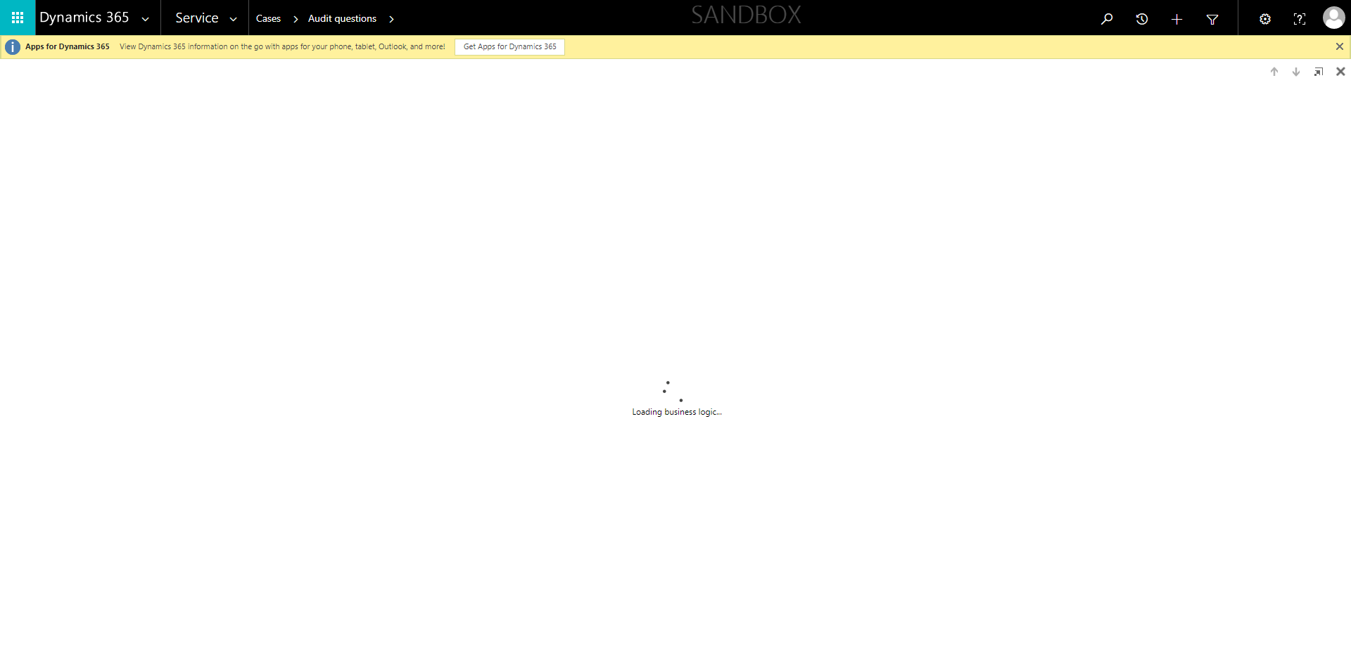

CaseManagement_TestForCaseEscalation_Instance29_12-Jul-2018_01-46-15_AM_EnterTextAction.png



CaseManagement_TestForCaseEscalation_Instance29_12-Jul-2018_01-49-58_AM_ValidatingDeEsclationofcasebyFLEuser.png

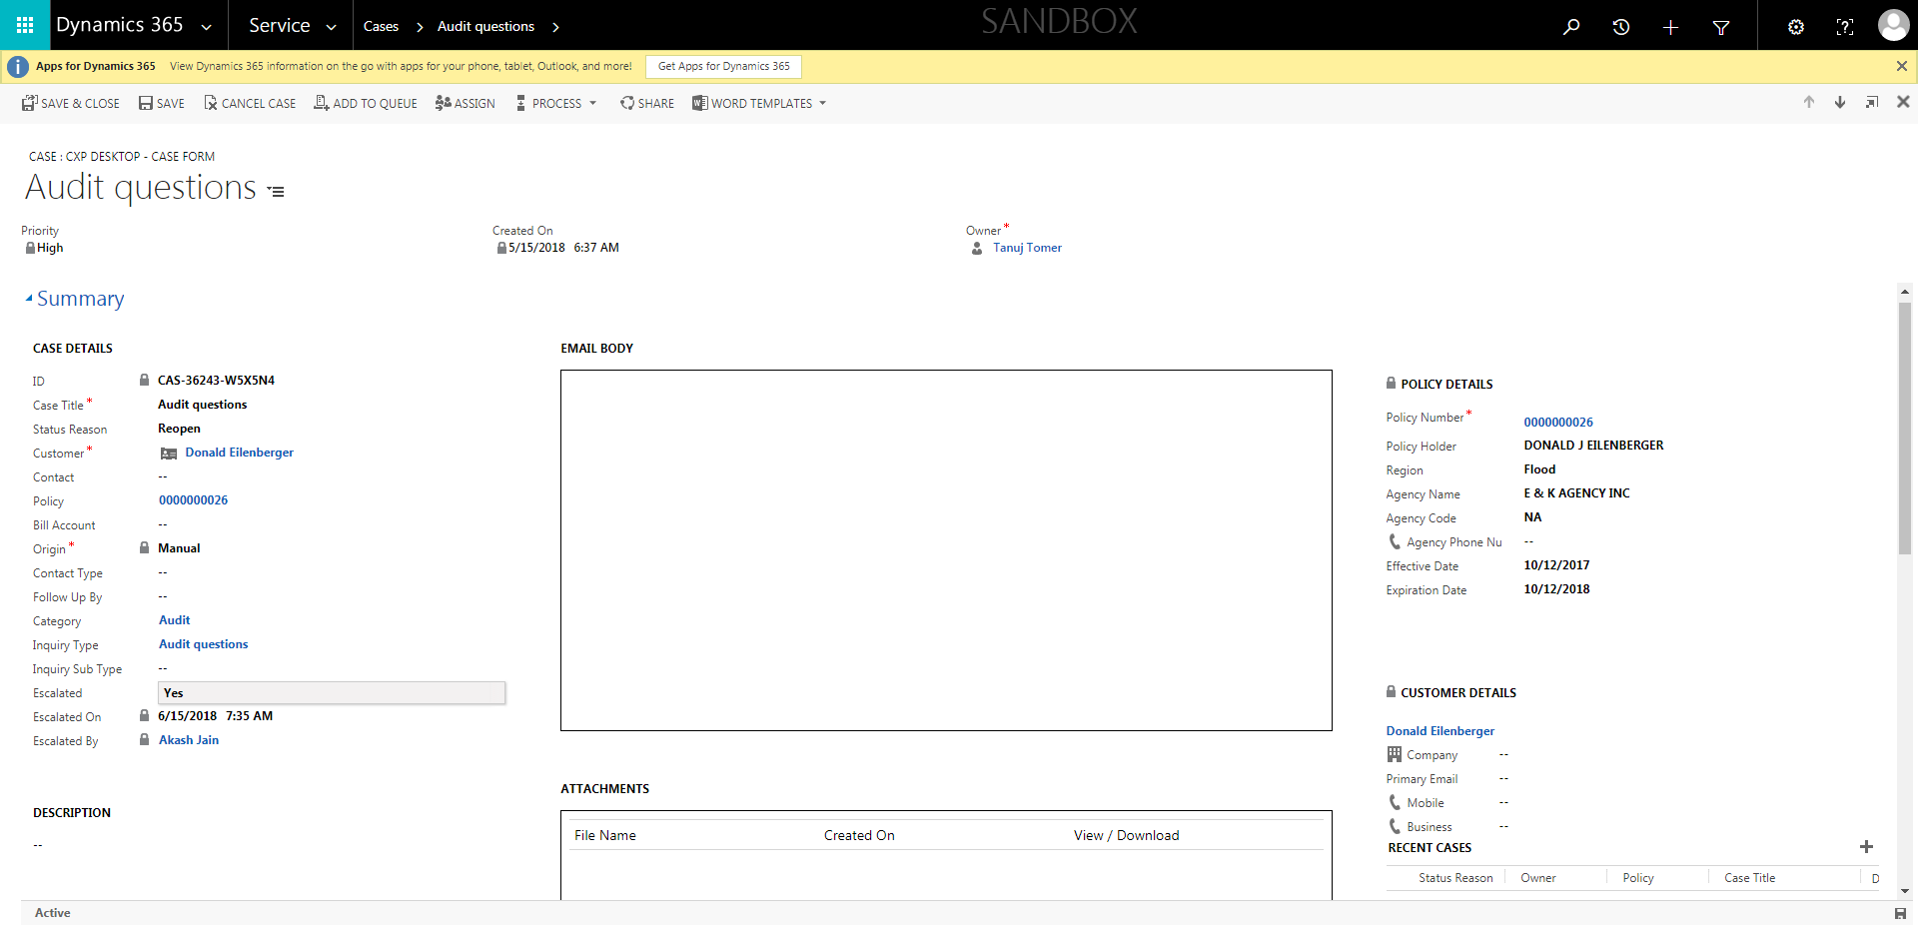

CaseManagement_TestForCaseEscalation_Instance29_12-Jul-2018_01-46-16_AM_MouseClickActiononStaleElement.png



CaseManagement_TestForCaseEscalation_Instance29_12-Jul-2018_01-47-59_AM_ValidatingCaseentitynavigation.png

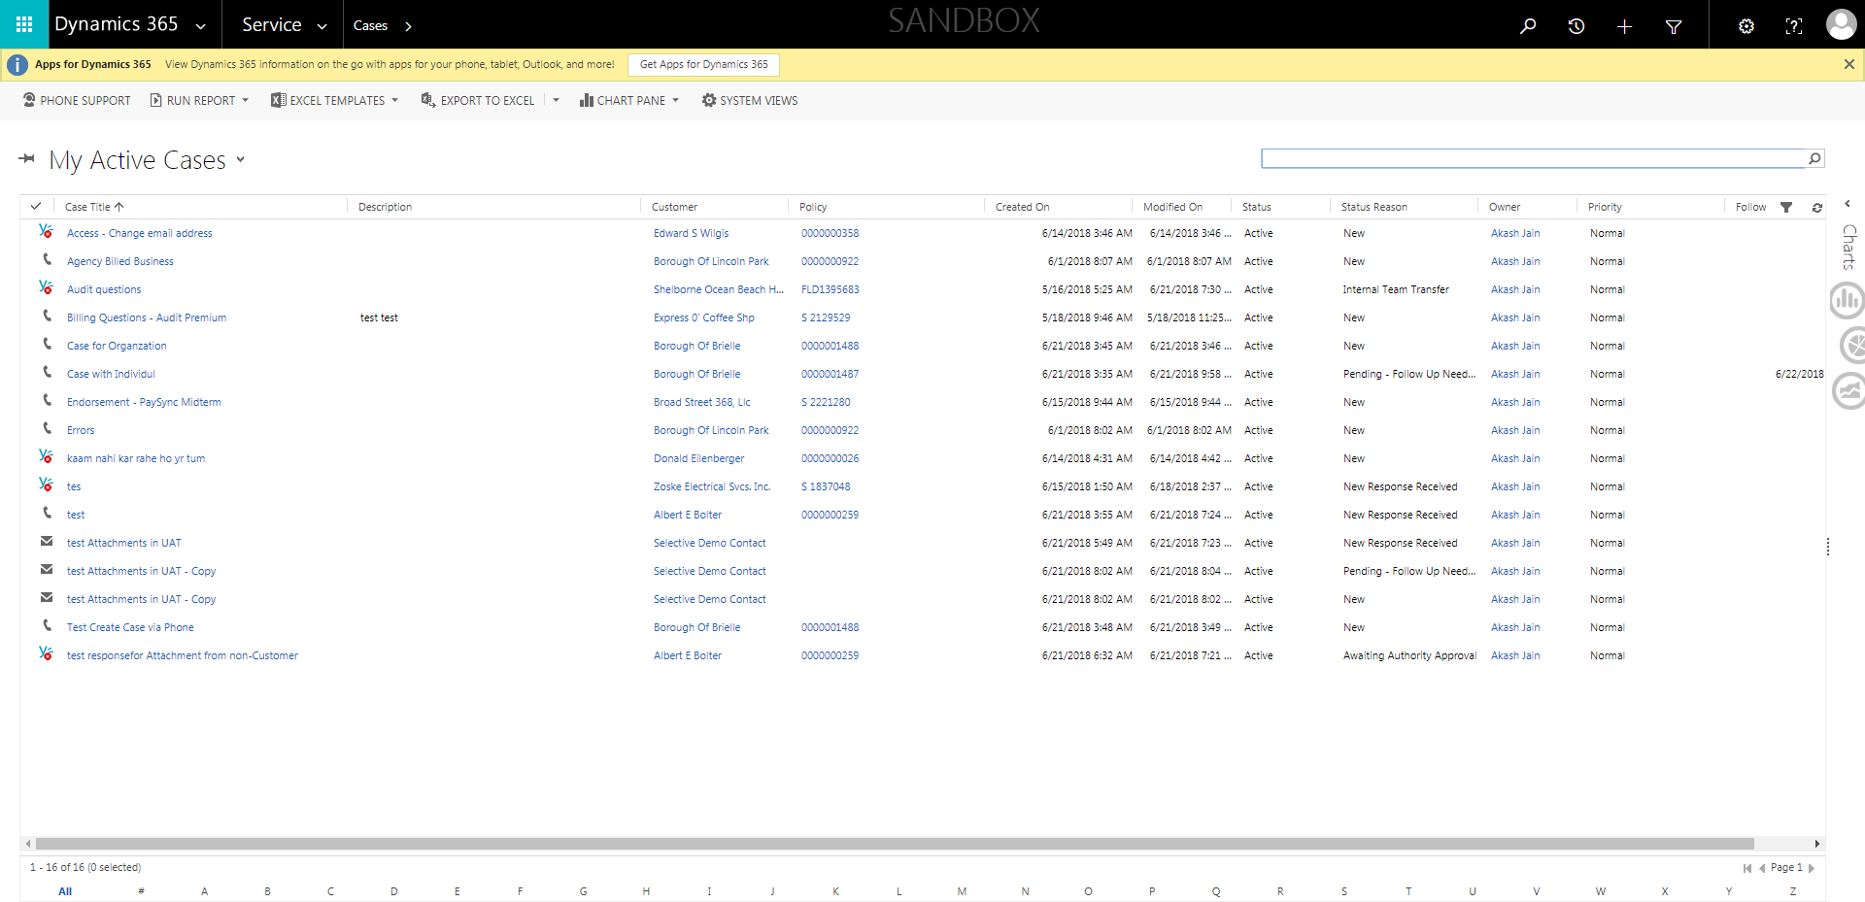

CaseManagement_TestForCaseEscalation_Instance29_12-Jul-2018_01-46-33_AM_SingleSignOn.png

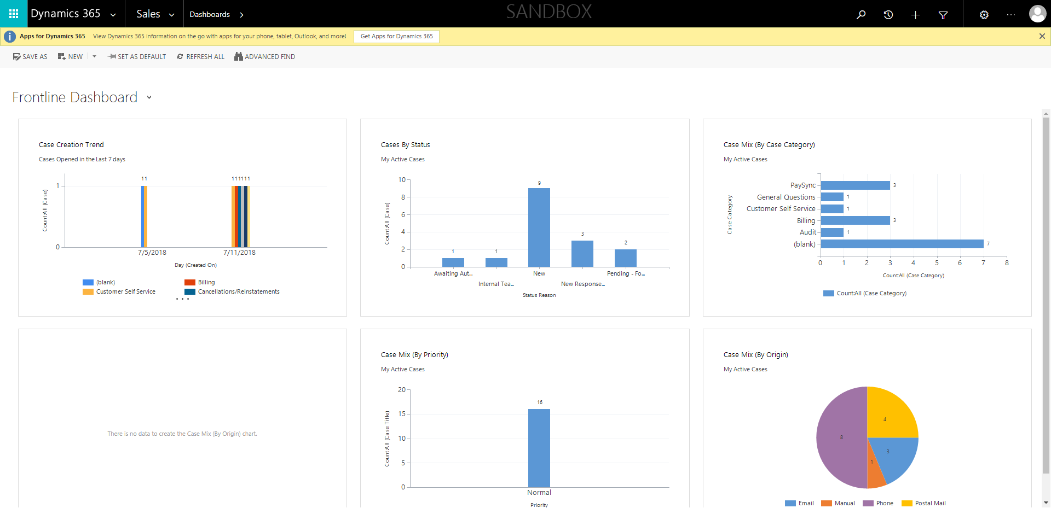

CaseManagement_TestForCaseEscalation_Instance29_12-Jul-2018_01-49-00_AM_ValidatingpresenceofEscalatedByField.png

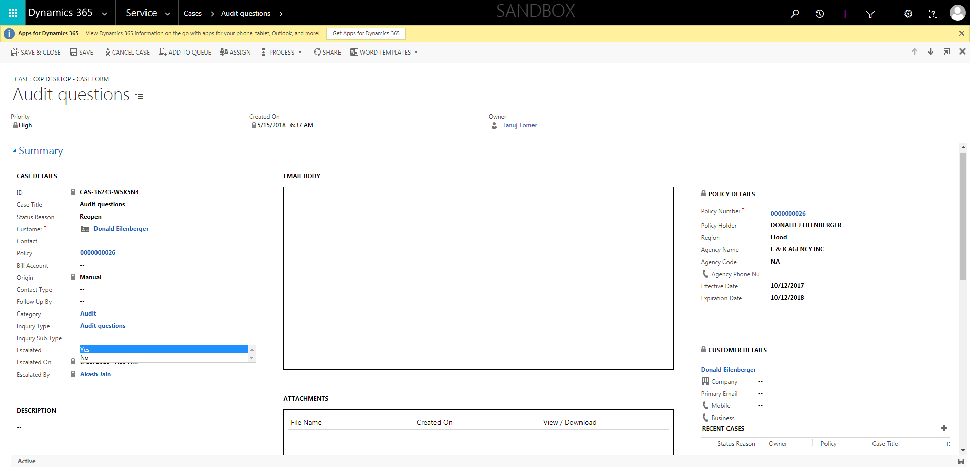

CaseManagement_TestForCaseEscalation_Instance29_12-Jul-2018_01-49-03_AM_ValidatingCaseOwnerChangesafterEscalatingCase.png

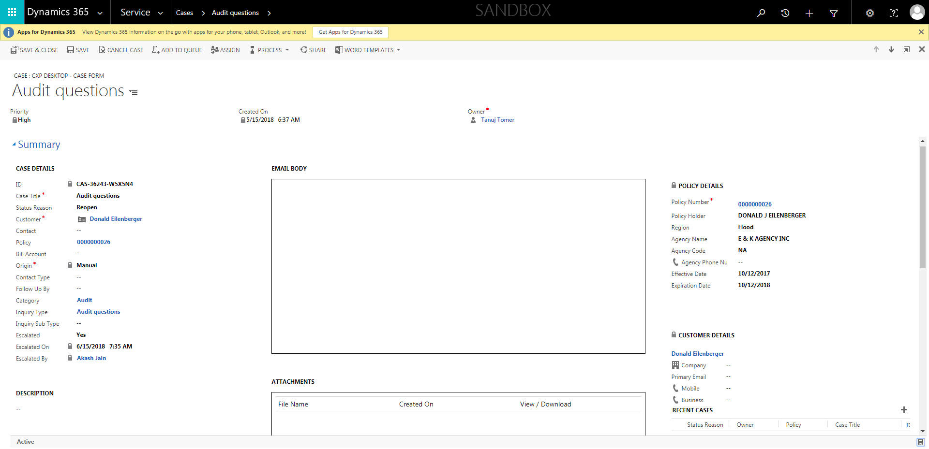

CaseManagement_TestForCaseEscalation_Instance29_12-Jul-2018_01-49-02_AM_ValidatingCaseEscalatedChanges.png



CaseManagement_TestForCaseEscalation_Instance29_12-Jul-2018_01-48-59_AM_GetTextFromElement.png

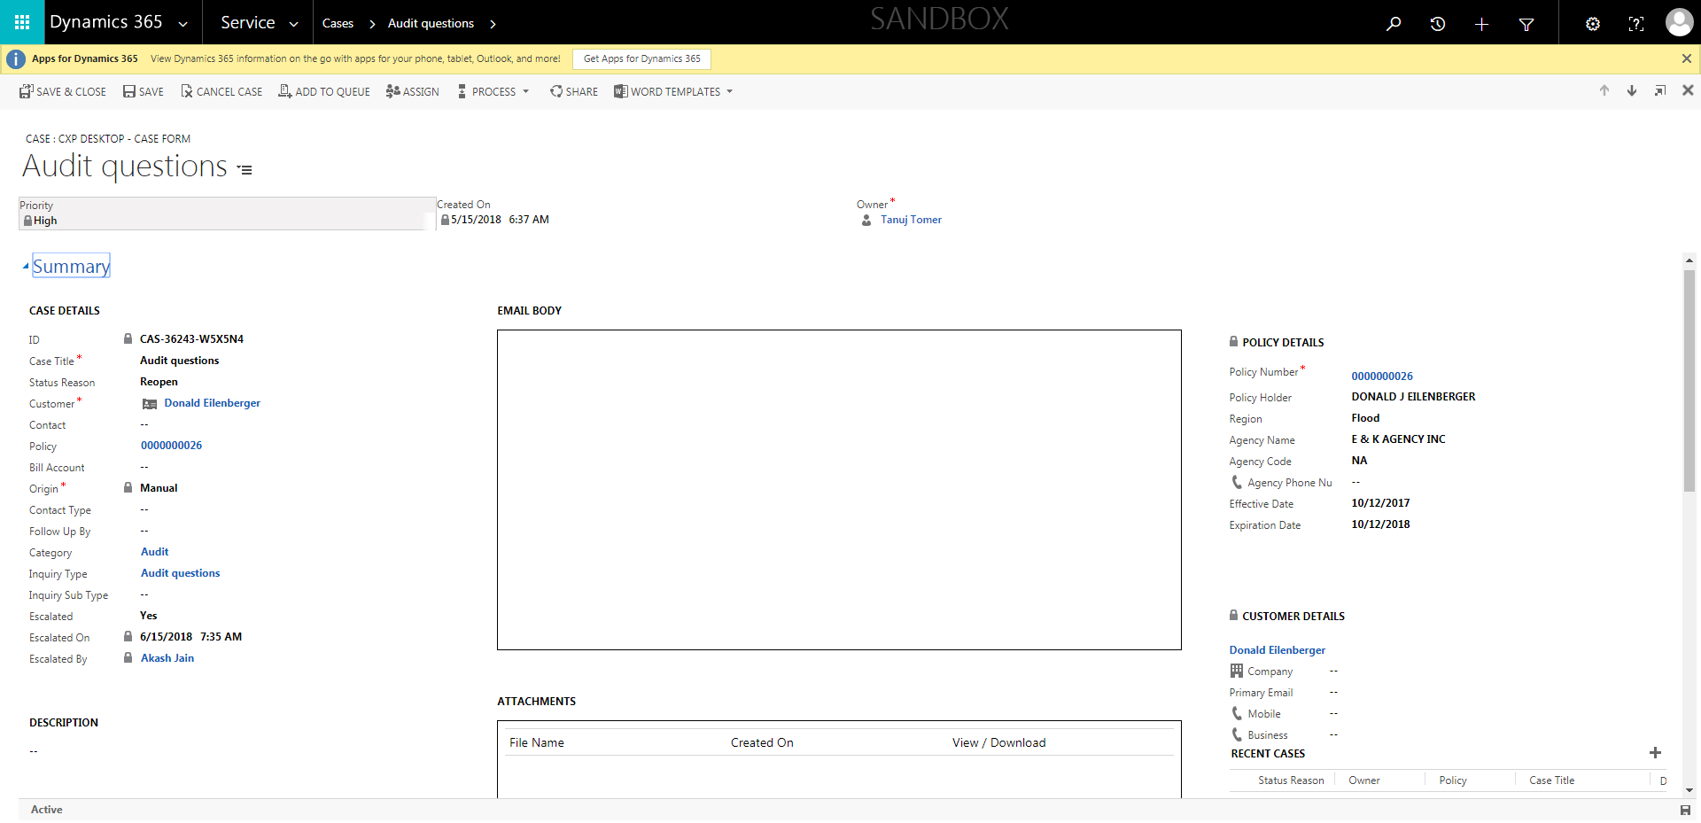

CaseManagement_TestForCaseEscalation_Instance29_12-Jul-2018_01-48-58_AM_ValidatingpresenceofReadonlyEscalatedByField.png



CaseManagement_TestForCaseEscalation_Instance29_12-Jul-2018_01-46-13_AM_MouseClickActiononStaleElement.png



CaseManagement_TestForCaseEscalation_Instance29_12-Jul-2018_01-50-53_AM_ValidatingManagerField.png

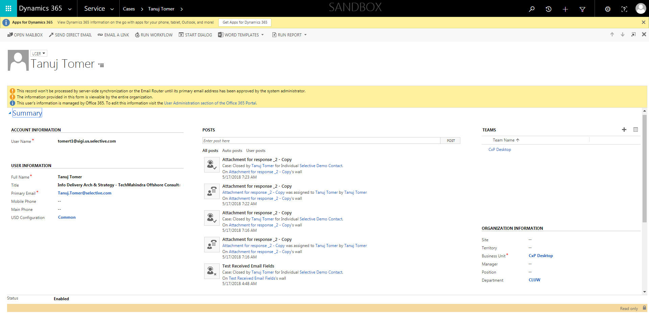

CaseManagement_TestForCaseEscalation_Instance29_12-Jul-2018_01-50-53_AM_GetTextFromElement.png

